Letter of Intent [Template]
[Find and replace all square brackets and complete/delete as appropriate]
From: To:
[Name of individual] Amy Whight
[Role of individual] Grants Manager
[Name of Anchor Institution] The Dixon Foundation
Background
Dynamic Purchasing UK and the [regional food hub] have approached us with an opportunity to participate in a match funding opportunity provided by The Dixon Foundation. We understand that the intent behind this funding is to a) establish regional infrastructure for Dynamic Food Procurement in [region] and b) initially implement dynamic food procurement within 1 to 3 counties within the [region] before rolling out to further counties.
We are aware that there is broad support for the Dynamic Food Procurement model due to the positive social, economic and environmental outcomes it has been shown to generate in pilots. The EFRA Select Committee, The National Food Strategy, The National Farmers Union, the Soil Association, Sustain, The Sustainable Food Trust and Sustainable Food Places all advocate widespread adoption for transformative benefit.
We are also aware that the level 2 and level 3 funding provided from The Dixon Foundation is dependent on anchor institutions match funding.
Our Commitments
- [Name of Anchor Institution] see the important role Dynamic Food Procurement can play in forming more transparent, short supply chains into our own and others’ catering operations in our region. Enabling more SME food producers and suppliers open access to our food contracts within the region could provide a triple multiplier effect for our regional economy. Supply chain transparency can also enable our own and other caterers in our region to make informed choices on the social and environmental impact of the food we buy. Given the food sector generates around a third of global greenhouse gases, progress in this area plays a critical play in our overall net zero planning.
and
- [Name of Anchor Institution] will convene other anchor institutions within our region to encourage them to adopt Dynamic Food Procurement approaches.
and
- [Name of Anchor Institution] is committed to implementing Dynamic Food Procurement, as per the National Food Strategy recommendation within our own catering operation.
and
- [Name of Anchor Institution] is committed to specifying a requirement to adopt Dynamic Food Procurement within our catering contract(s) which has a break event on <date>.
or
- [Name of Anchor Institution] is committed to converting our inhouse catering operations to adopt Dynamic Food Procurement to manage our supply chain from <date>.
And
- [Name of Anchor Institution] is committed to contributing to the setup costs of Dynamic Food Procurement; a) to establish [region] region infrastructure with all counties included by DPUK’s regional definition and b) implement dynamic food procurement. Specifically, for level 2 funding [Name of Anchor Institution] is prepared to contribute [£amount] by [date] and for level 3 funding [£amount] by [date] so long as the conditions stipulated in the ‘Financial Commitment Conditions’ section of this document below are met.
and
- [Name of Anchor Institution] are committed to providing up to [number] FTEs in procurement capability and capacity for the buying organisation.
and
- [Name of Anchor Institution] are committed to full participation in the regional plan below.

Our Regional Plan
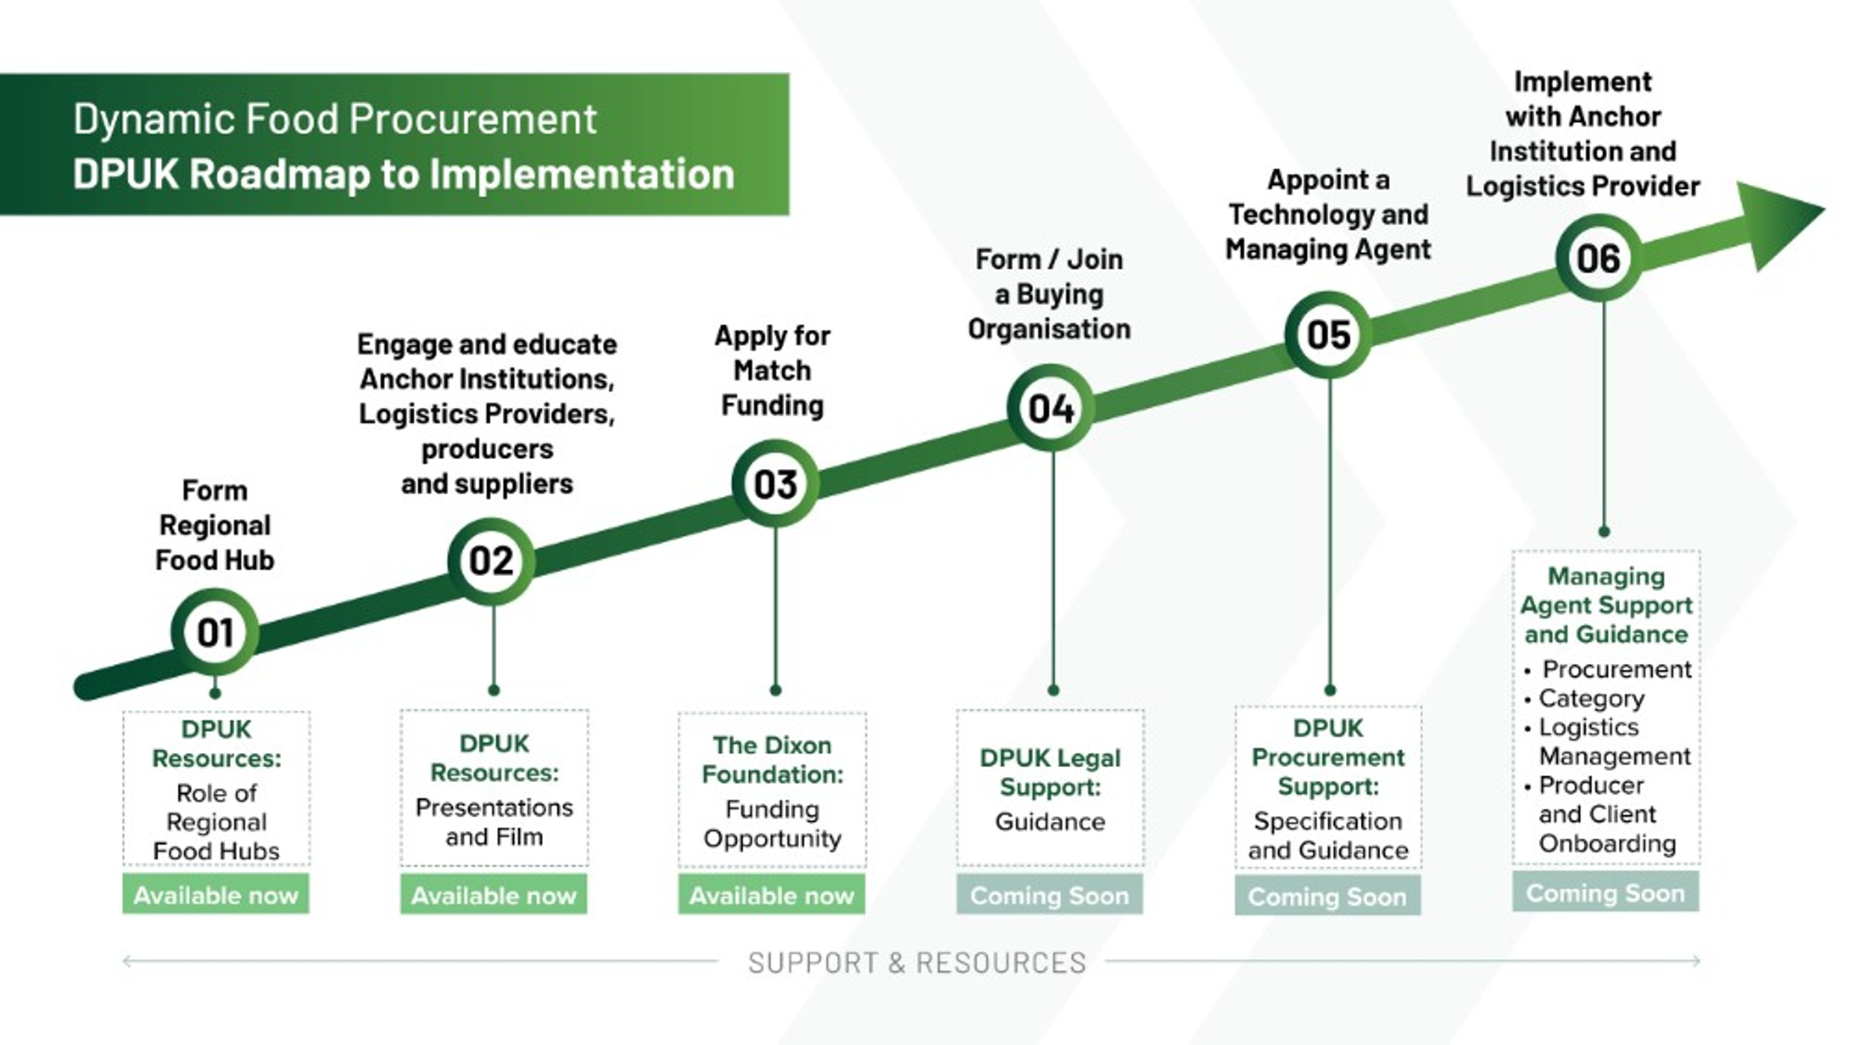

Forward Plan - Timeline
[date] Form/Join regional food hub
[date] Convene additional anchor institutions
[date] Engage with Logistics Providers, producers and suppliers to form short supply chains to fulfil catering product requirements
[date] Form/Join Buying Organisation hosting the procurements
[date] Transfer financial contribution into escrow account alongside The Dixon Foundation match funding
[date] Appoint Technology and Managing Agent
[date] Implement Dynamic Food Procurement in own and others’ catering operations

Financial Commitment Conditions
[Name of Anchor Institution] is committed to contributing financially to the set-up costs of Dynamic Food Procurement [in this region / and in this county.] so long as the conditions below are met:
- Creating regional infrastructure for dynamic food procurement
[Name of Anchor Institution] is committed to lend [x%] of £100,000 on condition of match funding from The Dixon Foundation and according to the lending terms below**. We understand other anchor institutions have been convened to provide the balance of the £100,000 lending required.

[Name of Anchor Institution] will lend these funds on the condition they are used for all of the following purposes and no other purposes:
- To appoint and fund a buying organisation capable of hosting the Dynamic Food Procurement*** Framework and procuring the technology and managing agent, logistics providers and food producers and suppliers.
- To appoint and fund the initial costs of a regional food hub capable of providing vision, engagement, education, enabling and executional support to anchor institutions, caterers, producers/suppliers and food logistics providers.
- To appoint and fund the initial costs of a technology and managing agent with the proven capability in the area of providing technology and management services in Dynamic Food Procurement*** and short supply chain logistics within the public sector catering environment. Technology modules must facilitate dynamic procurement, producer and supplier access, multiple logistics provider management of all stages of the supply chain and for end customer caterers and cooks to manage their orders, deliveries and invoice/billing via online and digital modules. Services and capabilities also include:
  - Project leadership and ongoing project management
  - Supplier and product procurement and awarding
  - User training and support / customer service
**[Name of Anchor Institution] understand that this will be perpetual debt that pays +2% interest above base rate from year 3 following the loan issue. [Name of Anchor Institution] understand these funds are lent at the risk of [Name of Anchor Institution] and may not be returned. The liability for this loan will sit with the Buying Organisation that is formed or joined for this purpose for which [Name of Anchor Institution] is a part.
***[Name of Anchor Institution] defines Dynamic Food Procurement consistent with the definition provided on the DPUK website here.
- Implementing dynamic food procurement in a county
[Name of Anchor Institution] is committed to granting [x%] of £50k funding for the county of [county] on the understanding that the balance of the funding requirement is met by other anchor institutions within [county] and on condition of match funding provided by The Dixon Foundation and on condition that the funds are used for all of the following purposes and no other purposes:

The appointed technology and managing agent must be able to evidence past proven technology and management capability in the area of implementing Dynamic Food Procurement*** within the public sector catering environment. The technology and managing agent will use these funds to fulfil the following responsibilities:
  - Provision of online stores for buyers – curated to feature the products required consistent with latest government buying standards.
  - Provision of logistics provider management, including supply chain dispute resolution.
  - Provision of accounting, finance & invoice/billing support.
  - Provision of technology integrations with Logistics Provider software and caterer accounting software
  - Provision of rigorous and granular data management from primary producer through each member of the chain to the buyer.

